**Algorithms and Data Structures – 2**

Module – 7 Bonus Activity 9

1. Implement the following shortest path API using the Dijkstra algorithm.

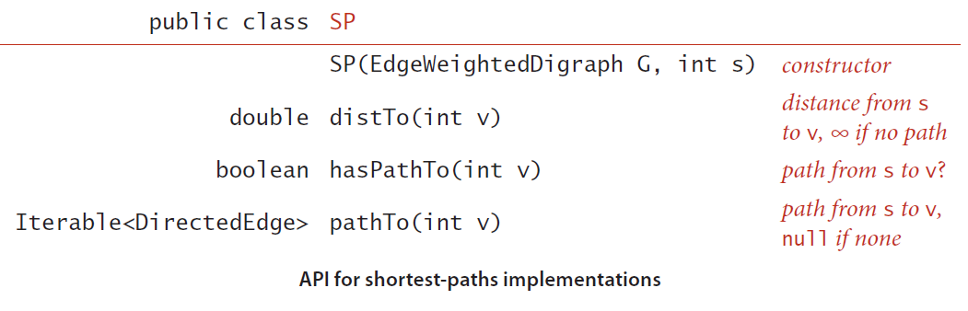

**Input:**

First Line indicates the number of the Vertices (V).

Second Line indicates the number of the Edges (E).

Third line contains the source vertex (S).

Next E lines contains 2 integers and weight which is double that are separated by spaces.

**Output:**

The first V lines contains the source to each vertex and a distance and the path from source to that vertex.

**Note:** Check for the test cases.